1. Logo change
2. Gg
3. GHVHVHVVHVHV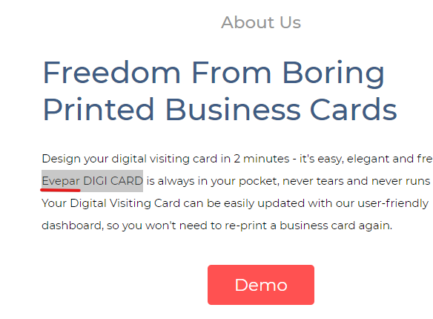

GSP BUSSINESS CARD



+9111-408-49909

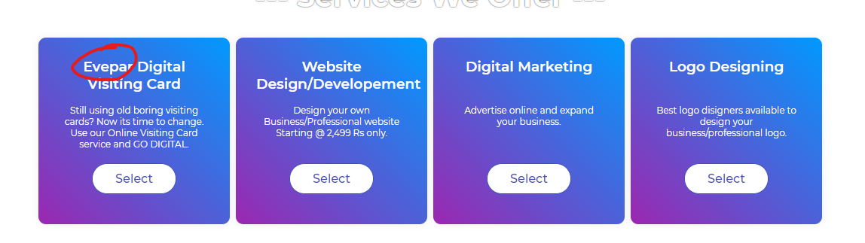

GSP



GSP Digital Business Card

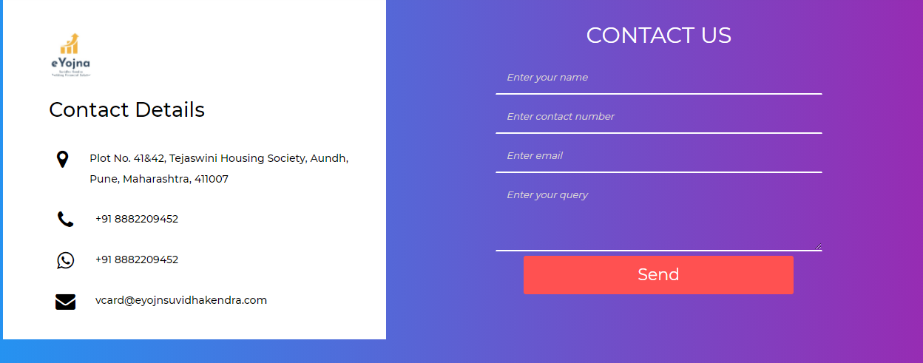

World Trade Centre, Electronic City, Bangalore Karnataka 560015

+9111-408-49909

[info@gstsuvidhaprovider.org.in](mailto:info@gstsuvidhaprovider.org.in)

contact us form ka details [info@gstsuvidhaprovider.org.in](mailto:info@gstsuvidhaprovider.org.in) pr bhej dijiyega



Logo change

© Copyright 2020 - All Rights Reserved. Crafted With GSP for Someone Special

Pls REMOVE - ! Support Forum | Faq's | Knowlege Base